

A Hybrid Explainable Framework for Context-Aware Consumer Complaint Resolution Recommendation Using Transformer Embeddings and Historical Case Retrieval

PROJECT REPORT

MTech Integrated CSE (Business Analytics)

Submitted for Project Based Component

CSE4077 - Recommender Systems

By

Hemila Saravanan – 23MIA1048
Lokireddy Madhavi – 23MIA1135

Slot: A1+TA1

Faculty Name: Dr S Vigneshwari (54147)

School of Computer Science and Engineering

October-2026

Report Structure

Topic | Page. No
1.Abstract | 3
2.Introduction | 3-5
3.Related Work | 5-8
4.Methodology | 8-11
5.Experimental Results &Discussion | 11-18
6.Conclusion & Future Work | 18-19
7.Refernces | 19-20

A Hybrid Explainable Framework for Context-Aware Consumer Complaint Resolution Recommendation Using Transformer Embeddings and Historical Case Retrieval

¹Hemila Saravanan, ²Lokireddy Madhavi,³S Vigneshwari
^{1,2,3} School of Computer Science and Engineering,
Vellore Institute of Technology, Chennai, India
hemila.saravanan2023@vitstudent.ac.in, lokireddy.madhavi2023@vitstudent.ac.in,s.vigneshwari@vit.ac.in

Abstract - Consumer complaint resolution is challenging due to the large volume of historical complaints. This study proposes an NLP-based recommendation system that combines transformer-based semantic embeddings, FAISS similarity search, and structured contextual features such as product, issue, company, timely response, and state to retrieve and rank relevant historical complaints. A hybrid ranking mechanism generates Top-K resolution recommendations based on historical outcomes. SHAP-based explainability provides insights into the factors influencing recommendations. The proposed framework integrates semantic retrieval, contextual ranking, historical resolution evidence, and explainability to support more relevant complaint routing and resolution guidance.

Keywords: Consumer Complaints, Natural Language Processing, Transformer Embeddings, FAISS, Semantic Similarity, Context-Aware Ranking, Resolution Recommendation, Explainable AI, SHAP, Complaint Management
1.Introduction
Consumer complaints are an important source of information for identifying problems experienced by users across financial and service sectors. Complaints may involve issues such as credit reporting, banking services, debt collection, unauthorized transactions, billing problems, and other consumer-related disputes. Although digital complaint management platforms have simplified complaint submission and storage, consumers may still face difficulties in identifying the appropriate complaint category, responsible organization, and suitable resolution pathway. Inefficient complaint routing can result in delays, repeated submissions, and increased effort for both consumers and service providers. Recent research has explored the use of Natural Language Processing (NLP) and Machine Learning (ML) to automate complaint classification, prioritization, and routing. For example, NLP and ML techniques have been applied to identify and prioritize complaints in e-governance systems [1], while automated complaint routing has been investigated using TF-IDF, BERT embeddings, and conventional machine-learning classifiers [2].
Traditional complaint-processing approaches generally rely on manually defined rules or conventional text-representation techniques. Although such methods can provide effective baseline classification, they may have limitations in capturing the contextual and semantic relationships within complaint narratives. AI-based complaint management systems using TF-IDF and LinearSVC have also been proposed to automate financial complaint classification [3]. Other studies have investigated complaint behavior from different perspectives, including sentiment, emotion, severity, and customer satisfaction. For instance, emotional and psychological factors have been analyzed in mobile banking complaints [4], while financial NLP research has explored domain-specific language processing and specialized transformer models [5]. Similarly, complaint detection frameworks have incorporated multiple dimensions such as complaint, severity, emotion, and sentiment to improve the analysis of financial-service complaints [6].
Despite these developments, existing approaches predominantly concentrate on classification, detection, prioritization, sentiment analysis, or routing rather than providing consumers with an intelligent recommendation regarding the likely resolution pathway. In addition, relying solely on complaint text may overlook important contextual information associated with a complaint. Structured attributes such as product, sub-product, issue, sub-issue, company, response timeliness, and geographical information can provide additional evidence for determining whether a historically resolved complaint is relevant to a new complaint. Research on digital complaint management has also highlighted the importance of understanding individual consumer concerns and addressing underlying complaint issues rather than focusing exclusively on procedural processing [7]. Furthermore, multitask learning approaches have demonstrated the benefit of jointly utilizing different characteristics of complaint text instead of treating complaint identification as an isolated task [8]. Studies of customer-agent interactions have similarly demonstrated that NLP can capture emotional and communication patterns that influence customer outcomes [9].
To address these limitations, this study proposes a Consumer Complaint Resolution Recommendation System Using Natural Language Processing. The proposed framework combines transformer-based semantic representation with efficient similarity retrieval using FAISS to identify historically similar complaints. Rather than stopping at retrieval, the proposed system incorporates structured complaint attributes to calculate contextual similarity between a new complaint and retrieved historical cases. Semantic similarity and contextual similarity are then combined through a hybrid ranking mechanism to prioritize the most relevant historical complaints. The historical resolution outcomes associated with these complaints are aggregated to generate Top-K resolution recommendations.
The proposed framework additionally incorporates an Explainable Artificial Intelligence (XAI) component to improve transparency. SHAP-based analysis is used to examine the contribution of the factors involved in the hybrid ranking and recommendation process. Thus, instead of merely returning similar complaints, the system provides an evidence-based recommendation supported by historical complaint outcomes and contextual information.

  - Motivation
The rapid growth of digital financial services has resulted in a substantial increase in the volume and complexity of consumer complaints. Financial institutions receive complaints related to issues such as unauthorized transactions, billing disputes, account management, payment problems, credit reporting, and other financial services. Efficiently analyzing and resolving these complaints is essential for improving customer satisfaction, reducing operational workload, and ensuring timely complaint handling. However, the large volume of complaint records makes purely manual analysis time-consuming and difficult to maintain. consistently Recent advances in Natural Language Processing (NLP) have enabled automated complaint classification, sentiment analysis, severity detection, prioritization, and routing. Although these approaches improve the identification and organization of complaints, they generally focus on determining what the complaint is about rather than identifying how a similar complaint was previously resolved. Consequently, valuable resolution knowledge contained in historical complaint records may not be fully utilized. Another limitation is that keyword-based or conventional text-matching approaches may fail to identify complaints that describe similar problems using different words or writing styles. Transformer-based language models provide a more effective mechanism for capturing semantic relationships between complaint narratives.
However, semantic similarity alone may retrieve complaints that are textually similar but differ in important contextual attributes such as product, issue, sub-issue, company, or timeliness. These limitations motivate the development of a context-aware complaint resolution recommendation system that combines semantic understanding with structured complaint information and historical resolution evidence. Instead of treating a new complaint as an isolated classification problem, the proposed approach retrieves relevant historical complaints, analyses their associated company responses, and ranks potential resolution pathways according to both semantic and contextual similarity.
Furthermore, for practical adoption in financial complaint management, recommendations should be interpretable and supported by evidence. Therefore, the proposed system incorporates explainability through similar historical cases and feature-importance analysis, allowing users to understand the basis of the recommended resolution pathways. The motivation of this work is thus to move beyond conventional complaint classification toward an evidence-based and explainable resolution recommendation paradigm.
1.2. Problem Statement
Financial institutions receive a large number of consumer complaints containing unstructured narratives, product information, issue categories, company details, and historical response information. Although existing complaint analytics approaches can classify complaints, detect sentiment, identify severity, or route complaints to appropriate categories, they provide limited support for determining an appropriate resolution for a newly received complaint. In particular, conventional classification-based approaches generally predict a predefined complaint category rather than utilizing previously resolved complaints as evidence for recommending a suitable resolution.
The problem is therefore formulated as the development of an intelligent complaint resolution recommendation framework that can understand the semantic content of a new consumer complaint, identify relevant historical complaints, and utilize their associated company responses to recommend appropriate resolutions. The framework should integrate complaint narratives with structured complaint attributes such as product, issue, sub-issue, and company information to improve contextual relevance. Furthermore, the recommended resolutions should be ranked according to their relevance to the current complaint and supported by interpretable evidence from similar historical cases. The proposed system is designed using the Consumer Financial Protection Bureau (CFPB) Consumer Complaint Database, which provides publicly available consumer complaint records for analysis.

1.3 Research Objectives
The primary objective of this study is to develop an NLP-based and explainable consumer complaint resolution recommendation framework that supports resolution decision-making using historical complaint cases. The study aims to establish a systematic preprocessing pipeline for consumer complaint narratives and associated structured attributes, followed by semantic analysis of complaint text using transformer-based representations. A semantic retrieval mechanism is developed to identify historically similar complaints and their associated company responses. The framework further integrates textual representations with structured attributes, including product, issue, sub-issue, and company information, to improve the contextual relevance of retrieved cases. Based on the retrieved historical evidence, the study aims to generate and rank potential resolution outcomes for a newly received complaint using a context-aware recommendation mechanism. Finally, explainable artificial intelligence techniques are incorporated to provide interpretable evidence for the recommendations, while retrieval and recommendation performance is assessed using metrics such as Precision, Recall, Mean Reciprocal Rank (MRR), and Normalized Discounted Cumulative Gain (NDCG), supported by comparative and ablation analyses
  - Key Contribution
The major contributions of this study are summarized as follows:
- Context-Aware Complaint Resolution Recommendation:
A novel NLP-based framework is proposed to recommend potential resolution pathways for new consumer complaints by learning from historically similar complaints and their associated company responses, rather than limiting the task to complaint classification or routing.
- Hybrid Complaint Representation: The framework combines semantic representations of complaint narratives with structured complaint attributes, including product, sub-product, issue, sub-issue, company, state, and timeliness, enabling both textual and contextual characteristics to be considered during recommendation.
- Transformer-Based Semantic Retrieval: Sentence-BERT is employed to generate dense semantic representations of complaint narratives. These representations enable the system to identify historically similar complaints even when their textual descriptions use different vocabulary or sentence structures.
- Efficient Historical Case Retrieval Using FAISS: A FAISS-based vector indexing mechanism is incorporated to efficiently retrieve the Top-K semantically similar historical complaints from a large complaint repository.
- Hybrid Similarity-Based Ranking: Semantic similarity is integrated with structured context similarity to improve the ranking of retrieved historical cases. This reduces the possibility of selecting complaints that are textually similar but contextually different.
- Historical Resolution Evidence for Recommendation: Company responses associated with highly ranked historical complaints are extracted and aggregated to generate ranked resolution recommendations for a new complaint. Thus, the system utilizes previously observed resolution outcomes as evidence for recommendation.
- Explainable Recommendation Mechanism: The proposed framework provides supporting historical cases and feature-importance information to explain the basis of its recommendations, improving transparency and interpretability for complaint-management applications.
- Comparative Evaluation with a Traditional NLP Baseline: The proposed transformer-based retrieval framework is compared with a conventional TF-IDF and Logistic Regression baseline to examine the effectiveness of semantic representations and context-aware retrieval for complaint analysis and resolution recommendation.

  - Organization of the Paper
The remainder of this paper is organized as follows. section 2 describes the limitations of conventional complaint analysis approaches and establishes the requirements for an automated, context-aware, and explainable resolution recommendation framework. Section 3n presents the proposed methodology. It describes the overall system architecture, dataset and data preparation, exploratory data analysis, complaint text preprocessing, baseline TF-IDF representation, transformer-based semantic representation using Sentence-BERT, historical complaint retrieval using FAISS, structured feature representation, hybrid similarity computation, context-aware ranking, historical resolution extraction, resolution pathway recommendation, and explainable AI. The experimental setup and evaluation methodology used to assess the proposed system are also presented in this section. Section 4 presents the experimental results and discussion. The performance of the conventional baseline and the proposed approach is evaluated and compared using appropriate classification, retrieval, and recommendation metrics. The effectiveness of semantic retrieval, contextual information, hybrid ranking, and resolution recommendation is analyzed. The section also discusses the explainability results and the contribution of individual components through ablation analysis discusses the implications, limitations, and practical applicability of the proposed framework. The potential use of the system in financial complaint-management environments, the importance of historical resolution evidence, and the limitations associated with historical-response-based recommendations are discussed. Finally, Section 5 concludes the paper by summarizing the major findings and contributions of the study and outlining directions for future research, including larger-scale evaluation, improved resolution-outcome modeling, domain-specific language models, real-time complaint processing, and more advanced explainable recommendation mechanisms.
2.Related Work
Recent research on consumer complaint analytics has increasingly employed Natural Language Processing (NLP), machine learning, deep learning, and large language models to automate complaint analysis and improve customer-service processes. Existing studies can broadly be categorized into complaint classification and prioritization, financial complaint analysis and prediction, transformer-based complaint understanding, and advanced NLP/LLM-based complaint analytics. However, most existing approaches focus on identifying, categorizing, predicting, or analyzing complaints rather than recommending suitable resolution pathways using historically resolved complaints.

2.1 NLP-Based Complaint Classification, Prioritization, and Management
Pallapu et al. (2026), in Smart Complaint Prioritization System using NLP and Machine Learning for E-Governance, proposed an NLP and machine learning framework for automatically prioritizing citizen complaints according to their importance and urgency [1]. The study demonstrated the potential of automated textual analysis and machine learning for improving complaint-handling efficiency. However, the work primarily addresses complaint prioritization in an e-governance setting and does not investigate semantic retrieval of historically similar complaints or resolution recommendation.
Saha et al. (2024), in Automated Complaint Classification and Routing Using NLP and Machine Learning, investigated automated complaint classification and routing to direct complaints to appropriate departments [2]. The study demonstrates the usefulness of NLP-based representations for reducing manual complaint-processing effort. Nevertheless, its objective remains classification and routing, without utilizing historical complaint-response relationships to recommend potential resolutions. The absence of context-aware resolution ranking and explainable recommendations leaves scope for a more decision-oriented complaint-management framework.
Desai and Kumar (2026), in AI-Based Complaint Management System Using NLP and Machine Learning, proposed an AI-based framework for categorization and prioritization of financial complaints [3]. The study highlights the potential of automated NLP and machine learning for handling large volumes of financial complaints. However, the framework focuses primarily on complaint categorization and prioritization rather than identifying similar historical cases and using their responses to recommend resolution pathways.
Singh et al. (2022), in Multitask Learning for Complaint Identification and Sentiment Analysis, proposed a multitask learning framework that jointly performs complaint identification and sentiment analysis [8]. The experiments used a complaint dataset containing customer-support tweets and demonstrated improved performance compared with corresponding single-task approaches. Although the approach provides useful linguistic representations for complaint analytics, its outputs remain focused on complaint identification and sentiment analysis rather than resolution recommendation. The study does not exploit historical complaint-response pairs for retrieval and ranking of potential resolutions.
Khedkar and Shinde (2020), in Deep Learning and Ensemble Approach for Praise or Complaint Classification, investigated deep learning and ensemble approaches for distinguishing praise from complaint-related customer feedback [17]. The study demonstrates the applicability of advanced learning techniques to automated complaint identification. However, the binary classification formulation does not address detailed complaint resolution, historical case retrieval, contextual ranking, or explainable recommendation.
Collectively, these studies demonstrate that NLP and machine learning can substantially automate complaint identification, categorization, prioritization, and routing. However, they generally treat complaint processing as a classification or triage problem, rather than as a historical case-based resolution recommendation problem.
2.2 Financial Complaint Analysis and Outcome Prediction
Alarifi et al. (2023), in Prediction and Analysis of Customer Complaints Using Machine Learning Techniques, investigated Logistic Regression and Support Vector Machine (SVM) models for predicting and analyzing financial complaints using multiple time-window datasets obtained from the Consumer Financial Protection Bureau (CFPB) [10]. The study used five CFPB datasets covering one month, three months, six months, one year, and three years, and applied TF-IDF for textual feature transformation. The results demonstrated the usefulness of conventional machine learning for financial complaint prediction and analysis. However, the task remains prediction-oriented and does not retrieve semantically similar historical complaints or use previous company responses to generate ranked resolution recommendations.
Vaishnav et al. (2024), in Predictive Analysis of CFPB Consumer Complaints Using Machine Learning, further investigated machine learning approaches for analyzing CFPB consumer complaints [11]. The study demonstrated that historical CFPB complaint records can be used to model complaint-related and company-response characteristics. This work is particularly relevant because it establishes the usefulness of the CFPB dataset for predictive financial complaint analytics. Nevertheless, the formulation remains prediction-oriented and does not address semantic retrieval of similar historical cases or context-aware recommendation of resolution pathways.
Wang et al. (2026), in From Complaint Narratives to Monetary Relief: A Hybrid Machine Learning Framework for CFPB Consumer Complaints, proposed a hybrid machine learning approach for predicting monetary-relief outcomes from CFPB complaints [12]. The framework combines complaint narratives with engineered textual and structured features to predict monetary-relief outcomes. The study demonstrates the value of integrating textual and structured information for financial complaint outcome modeling. However, monetary relief is formulated as a specific prediction target rather than as a general resolution recommendation task. The framework does not retrieve similar historical complaint-response cases and rank their associated resolutions for a new complaint.
Trusov et al. (2024), in A Transformer-Based Framework for Customer Complaint Analytics, proposed a transformer-based framework for analyzing customer complaints [19]. The study demonstrated the effectiveness of transformer architectures in capturing contextual information from complaint narratives and improving automated complaint analytics. However, the framework primarily addresses complaint analytics rather than retrieval-driven resolution recommendation. The study does not integrate historical complaint-response pairs with structured complaint attributes to produce context-aware and explainable resolution rankings.[19]. Gao et al. (2024), in NLP-Based Detection of Systematic Anomalies among the Narratives of Consumer Complaints, investigated NLP techniques for identifying systematic anomalies within consumer complaint narratives [16]. The study demonstrates that large-scale complaint narratives can be analyzed to identify unusual or systematic patterns. However, anomaly detection primarily supports monitoring and pattern discovery and does not directly provide a resolution recommendation for an individual complaint.
These studies establish the importance of the CFPB Consumer Complaint Database for financial complaint analytics and demonstrate that both textual and structured complaint attributes can support predictive modeling. However, their primary objectives remain prediction, outcome modeling, or anomaly detection, rather than historical resolution retrieval and recommendation.
2.3 Financial NLP, Sentiment, Emotion, and Consumer Behavior
Le Li et al. (2026), in Understanding Complaint Behavior in Mobile Banking: A Psychological and AI-Based Analysis of Emotional Drivers, examined the psychological and emotional factors associated with complaints in mobile banking [4]. The study highlights the importance of emotional characteristics for understanding consumer dissatisfaction. However, emotional and behavioral analysis is not extended to historical case retrieval or resolution recommendation.
Athira et al. (2025), in Effective Complaint Detection in Financial Services through Complaint, Severity, Emotion and Sentiment Analysis, proposed a framework integrating complaint detection, severity analysis, emotion analysis, and sentiment analysis for financial-service complaints [6]. The study demonstrates that multiple linguistic characteristics can provide a more comprehensive representation of consumer complaints. Nevertheless, the framework concentrates on complaint detection and characterization rather than using historical complaint-response information to recommend resolutions.
De Cleen et al. (2025), in The Influence of Emotions and Communication Style on Customer Satisfaction and Recommendation in a Call Center Context: An NLP-Based Analysis, investigated the relationship between emotions, communication style, customer satisfaction, and recommendation behavior in a call-center context [9]. The findings indicate that linguistic and emotional characteristics provide valuable information about customer satisfaction. However, the study focuses on understanding customer responses rather than recommending operational resolution pathways for individual complaints.
Yadav et al. (2026), in Empowering the Voice of Individual Consumers in the Era of Digitalisation and Quality 4.0, emphasized the importance of systematically analyzing consumer feedback and complaint information for improving service quality and organizational decision-making [7]. Although the work strengthens the case for data-driven consumer-feedback analysis, it does not provide a dedicated retrieval-based mechanism for identifying similar historical complaints and recommending their associated resolutions.

2.4 Transformer-Based and Advanced NLP Approaches
Uysal et al. (2025), in Enhancing Financial NLP with Supercomputing: Spell Correction and Domain-Specific BERT Pretraining, investigated financial-domain NLP using spell correction and domain-specific BERT pretraining [5]. The study demonstrates the importance of domain-specific language representation for financial text processing. Although this provides a strong foundation for transformer-based financial NLP, the study does not address historical complaint retrieval or resolution recommendation.
Xu et al. (2025), in Understanding Customer Complaints from Negative Online Hotel Reviews: A BERT-Based Deep Learning Approach, applied BERT-based deep learning to identify and analyze complaint information in negative hotel reviews [18]. The study provides evidence that contextual transformer representations can improve the understanding of customer-generated complaint text. However, its application domain is hotel reviews rather than financial consumer complaints, and the framework does not perform historical complaint-response retrieval or resolution recommendation.
Roumeliotis et al. (2025), in Think Before You Classify: The Rise of Reasoning Large Language Models for Consumer Complaint Detection and Classification, investigated reasoning-oriented large language models for consumer complaint detection and classification [13]. The study highlights the increasing capability of advanced language models to process complex complaint narratives. Nevertheless, the task remains centered on detection and classification and does not extend reasoning toward retrieval-based resolution recommendation or context-aware ranking of alternative resolutions.
Gao et al. (2026), in NLP-Based Consumer Complaint Assessment: Synthetic Data Generation, Featurization, and Evaluation Metrics, investigated complaint assessment using synthetic data generation, feature engineering, and evaluation strategies [14]. The study emphasizes the importance of effective representation and evaluation in consumer complaint analytics. However, the primary focus is complaint assessment rather than retrieval-based resolution recommendation, and the use of synthetic data does not directly address the exploitation of historical real-world complaint-response relationships.
Shin et al. (2026), in The Adoption and Efficacy of Large Language Models in US Consumer Financial Complaints, examined the adoption and effects of LLM-assisted complaint writing using 1,134,512 CFPB complaints from 2015–2024, together with controlled experiments involving 1,010 participants [15]. The study found that LLM-assisted complaint presentation was associated with an increased probability of obtaining favourable relief and demonstrated the growing relevance of LLMs in financial consumer complaints. However, the research focuses on the effect of LLM use on complaint presentation and consumer outcomes rather than on recommending resolutions for newly received complaints based on historical complaint-response cases. This transformer and LLM studies demonstrate the increasing importance of contextual language representations for complaint understanding. Nevertheless, transformer-based semantic representations have not been sufficiently integrated with efficient historical case retrieval, structured complaint context, resolution-outcome aggregation, and explainable ranking within a unified complaint-resolution framework.

2.5 Research Gap
Existing research on consumer complaint analytics has primarily focused on complaint classification, prioritization, routing, sentiment and emotion analysis, severity detection, and prediction of complaint outcomes. These approaches have demonstrated the effectiveness of machine learning, deep learning, and transformer-based natural language processing for understanding complaint narratives; however, their primary objective remains the identification or prediction of complaint characteristics rather than recommending an appropriate resolution for a newly received complaint. Recent studies on financial consumer complaints have also explored predictive modeling and the relationship between complaint narratives and outcomes, but limited attention has been given to retrieving relevant historical complaint cases and using their associated resolution outcomes as evidence for resolution recommendation.
Furthermore, many existing approaches rely predominantly on textual representations or predefined structured categories independently, without jointly exploiting semantic information from complaint narratives and contextual attributes such as product, issue, sub-issue, and company. Consequently, semantically relevant historical cases may not be sufficiently distinguished according to their contextual similarity. The use of transformer models has improved semantic understanding, but their application has largely concentrated on classification, detection, or analysis tasks rather than retrieval-driven resolution recommendation. In addition, existing complaint analytics systems provide limited interpretability regarding why a particular outcome or recommendation is produced, which restricts their usefulness in decision-support environments where transparency is important. These limitations indicate the need for a framework that combines transformer-based semantic understanding, historical complaint retrieval, structured contextual information, resolution ranking, and explainable recommendation within a unified architecture.

3.Proposed Methodology
3.1 System Overview
The proposed system is an NLP-based Consumer Complaint Resolution Recommendation System designed to identify relevant historical complaints and recommend suitable resolution pathways for a newly submitted complaint. The system utilizes both the unstructured complaint narrative and structured complaint attributes available in the CFPB Consumer Complaint Database.
The overall methodology consists of complaint data preparation, text preprocessing, transformer-based semantic representation, FAISS-based similar complaint retrieval, structured context analysis, hybrid ranking, resolution recommendation, and explainable AI. When a new complaint is provided, the system retrieves the most similar historical complaints and refines their ranking using contextual information. The resolution outcomes associated with the highly ranked complaints are then used to generate the final recommendation.

The proposed system architecture for context-aware consumer complaint resolution recommendation is illustrated in Fig. 1. The framework is designed to analyze consumer complaint narratives together with relevant structured complaint attributes and recommend suitable resolution pathways based on historically resolved complaints. The architecture consists of ten major modules: data source, data preprocessing, feature representation, semantic retrieval, new complaint processing, online retrieval and ranking, historical response extraction, context-aware resolution recommendation, explainable AI, and evaluation.
The CFPB Consumer Complaint Database is used as the primary data source. Each complaint may contain a narrative along with structured attributes such as product, sub-product, issue, sub-issue, company, state, timeliness, and company response. During preprocessing, duplicate records, missing values, irrelevant records, and unsuitable complaint narratives are handled. The textual narratives are normalized before feature extraction, while categorical attributes are prepared for structured feature representation.
The feature representation module employs two complementary approaches. TF-IDF is used as the traditional baseline representation, whereas Sentence-BERT is used to generate dense semantic representations of complaint narratives. In addition, structured attributes such as product, sub-product, issue, sub-issue, company, state, and timeliness are encoded to capture the contextual characteristics of each complaint.6
For efficient historical complaint retrieval, the transformer-based embeddings of the historical complaints are stored in a FAISS vector index. When a new complaint is received, its narrative is transformed into a Sentence-BERT embedding and its structured attributes are extracted. The resulting query representation is compared against the indexed historical complaints using semantic similarity search.
The online retrieval and ranking module first retrieve the Top-K semantically similar historical complaints. Since semantic similarity alone may retrieve complaints with different contextual characteristics, a structured context similarity component is incorporated. The semantic similarity and context similarity are combined through a hybrid ranking mechanism to obtain a more context-aware ranking of historical complaints.
The historical response extraction module obtains the company responses associated with the highly ranked complaints. These historical responses are aggregated to identify frequently occurring resolution outcomes among the most relevant cases. The aggregated outcomes are then passed to the context-aware resolution recommendation module, which generates a ranked list of Top-K recommended resolution pathways for the new complaint.
To improve transparency, the Explainable AI module provides supporting evidence for each recommendation using the retrieved historical cases and feature-importance information. This enables the system to indicate why a particular resolution pathway is recommended rather than producing an unexplained prediction. Finally, the evaluation

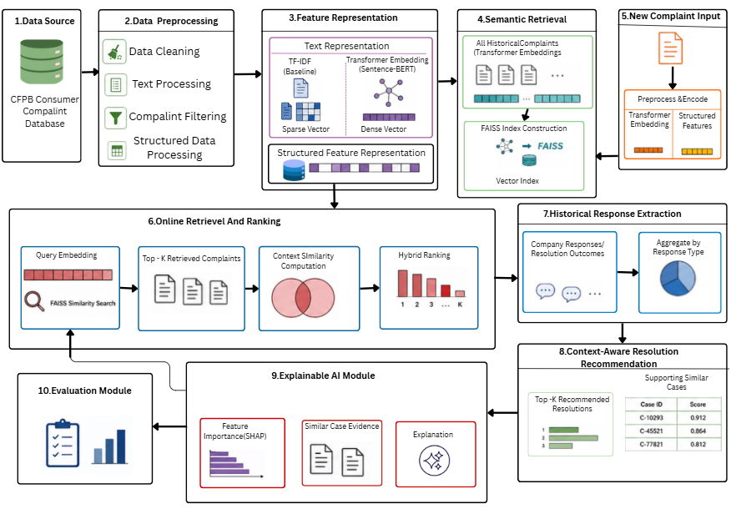

Fig. 1 System architecture of the proposed context-aware consumer complaint resolution recommendation system.

3.2 Data Preparation and NLP Processing
The Consumer Financial Protection Bureau (CFPB) Consumer Complaint Database was used as the primary data source for developing the proposed consumer complaint resolution recommendation system. The dataset contains consumer complaint narratives together with structured attributes such as product, sub-product, issue, sub-issue, company, state, timely response, and company response. These attributes provide both textual and contextual information for identifying historically similar complaints and their corresponding resolution outcomes.
A systematic preprocessing procedure was applied to improve data quality and ensure consistency before feature extraction. Duplicate records were identified and removed, while irrelevant attributes that did not contribute to complaint analysis were excluded. Missing values in structured attributes were handled appropriately, and textual complaint narratives were normalized by converting text to a consistent format and removing unnecessary characters and noise. The resulting dataset was subsequently used for exploratory analysis, feature engineering, semantic representation, and historical complaint retrieval.The preprocessing stage produced a standardized complaint dataset in which each complaint was represented by its narrative text and relevant structured attributes. This processed dataset formed the foundation for both the conventional TF-IDF baseline and the proposed transformer-based semantic retrieval framework.
The cleaned complaint text is then passed to a transformer-based sentence embedding model to obtain a numerical representation of its semantic meaning.
The overall workflow of the proposed framework is illustrated in Fig. 2. The methodology begins with the preparation of the CFPB Consumer Complaint Database, followed by text preprocessing and feature representation using Sentence-BERT embeddings and structured complaint attributes. FAISS is employed to retrieve the top-10 semantically similar historical complaints, which are subsequently re-ranked using a hybrid semantic–contextual similarity score. The associated historical company responses are aggregated to generate ranked resolution recommendations. Finally, explainability and evaluation procedures are applied to examine the recommendation process and its performance.

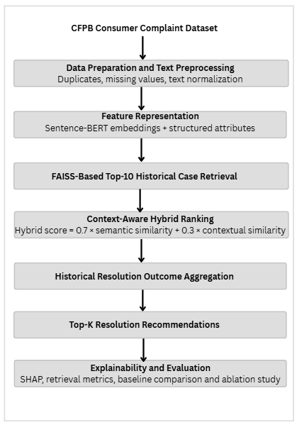

Fig. 2. Workflow of the proposed context-aware consumer complaint resolution recommendation methodology

For each complaint $C_{i}$, its embedding is represented as in eq.1.
$${ E}_{i}=f\left(C_{i}\right) (1)$$
where $f$represents the embedding model and $E_{i}$is the resulting semantic vector.
For a new complaint $C_{q}$, its embedding is similarly obtained in eq.2.
$$E_{q}=f\left(C_{q}\right) (2)$$
These embeddings provide the semantic representation required for similarity-based retrieval.

3.3 Semantic Retrieval and Context-Aware Ranking
The generated complaint embeddings are indexed using FAISS (Facebook AI Similarity Search). FAISS enables efficient retrieval of historically similar complaints from the indexed complaint collection. The similarity between the query complaint and a historical complaint is measured using cosine similarity represented in eq.3.
$$Sim\left(E_{q} , E_{i}\right)=\frac{E_{q}⋅E_{i}}{∥E_{q}∥∥E_{i}∥} (3)$$
where $E_{q}$is the query embedding and $E_{i}$is the embedding of the $i^{th}$historical complaint.
The system retrieves the Top-10 historical complaints with the highest semantic similarity scores. However, semantic similarity alone may not fully capture the contextual relevance of a complaint. Therefore, structured attributes including product, sub-product, issue, sub-issue, company, timely response, and state are compared between the query complaint and each retrieved complaint.
For $m$structured attributes, contextual similarity can be represented as:
Where $q_{j}$represents the $j^{th}$attribute of the query complaint, $i_{j}$represents the corresponding attribute of the historical complaint and $I\left(⋅\right)$is an indicator function that returns 1 when the attributes match and 0 otherwise.
The semantic and contextual similarity values are then combined to obtain the hybrid ranking score using eq.4.
$$HybridScore_{i}=αSim\left(E_{q} , E_{i}\right)+\left(1-α\right)ContextSim\left(q , i\right) (4)$$
In the implemented system, $α=0.7$, giving using eq.5.
$HybridScore_{i}=0.7Sim\left(E_{q} , E_{i}\right)+ 0.3ContextSim\left(q , i\right) (5)$
The retrieved complaints are subsequently re-ranked according to their hybrid scores.

3.4Resolution Recommendation and Explainability
After context-aware ranking, the historical resolution outcomes associated with the retrieved complaints are analyzed. These outcomes are represented using the company_ response field in the dataset. Examples include Closed with explanation, closed with monetary relief, and closed with non-monetary relief. For a resolution category $r$, its support among the retrieved cases can be calculated using eq.6.
$$Support\left(r\right)=\frac{N_{r}}{K} (6)$$
where $N_{r}$is the number of retrieved complaints associated with resolution $r$, and $K$is the number of retrieved complaints considered for recommendation.
The resolution categories are ranked according to their historical support and relevance among the retrieved cases. The highest-ranked categories form the Top-K resolution recommendations.
To improve transparency, an Explainable AI (XAI) component using SHAP is incorporated. SHAP represents the contribution of individual input features to a model output as shown in eq.7.
$f\left(x\right)=ϕ0​+j=1∑M​ϕj​ (7)$
Where $f\left(x\right)$is the model or scoring output, $ϕ_{0}$is the expected baseline output, $ϕ_{j}$represents the contribution of feature $j$, $M$is the number of features.

In the implemented ranking explanation, SHAP is used to analyze the contribution of semantic similarity and contextual similarity to the hybrid ranking score. This helps explain why a particular historical complaint received a higher ranking.

3.5 Final Recommendation and System Evaluation
The final system produces an integrated recommendation containing the Top-10 similar historical complaints, complaint category and context, similarity scores, hybrid ranking scores, and Top-K historical resolution outcomes. The SHAP explanation provides additional evidence regarding the factors contributing to the ranking.
The overall recommendation process can be represented using eq.8
$$Recommendation=f(SemanticSimilarity, ContextSimilarity,$$
$HistoricalResolution ) (8)$

The system is evaluated at different stages of the pipeline. Semantic retrieval is assessed based on the relevance of retrieved historical complaints, while the ranking component is evaluated using the hybrid scores. The resolution recommendation is analyzed based on the historical resolution distribution among the relevant retrieved cases. The explainability component is examined based on the contribution of the semantic and contextual features to the ranking.

Algorithm :1 Consumer Complaint Resolution Recommendation

Input: New complaint Cq, historical complaint dataset D
Output: Top-K resolution recommendations and explanations
Initialize:
embedding model f, FAISS index, semantic weight α = 0.7, context weight β = 0.3
1: Read complaint Cq
2: Preprocess Cq
3: Eq ← f(Cq)
4: Normalize Eq
5: Retrieve Top-10 similar complaints using FAISS 6: For each retrieved complaint Ci do
7: Calculate semantic similarity Si
8: Extract structured complaint attributes
9: Calculate contextual similarity Ci
10: Hi ← 0.7Si + 0.3Ci
11: End For
12: Rank complaints according to Hi
13: Extract historical resolution outcomes
14: Calculate resolution outcome support
15: Generate Top-K resolution recommendations 16: Apply SHAP to explain hybrid ranking
17: Return ranked complaints, recommendations, and explanations
18: End Algorithm

Algorithm :2 Historical Resolution Recommendation

Input: Ranked complaint cases R
Output: Top-K resolution recommendations
Initialize resolution outcome set O

1: Receive hybrid-ranked complaint cases
2: For each complaint Ci in R do
3: Extract historical resolution outcome Oi
4: Retrieve hybrid ranking score Hi
5: End For
6: Group complaints according to their resolution outcomes
7: For each resolution outcome r do
8: Calculate outcome frequency Nr
9: Calculate Support(r) = Nr / K
10: Calculate Weighted Score(r) = Σ Hi for Oi = r
11: End For
12: Rank resolution outcomes using Weighted Score
13: Select Top-K resolution outcomes
14: Return recommended outcomes with supporting cases
15: End Algorithm

4.RESULTS AND DISCUSSIONS
4.1 Experimental Results
The proposed Consumer Complaint Resolution Recommendation System was evaluated using a subset of 1,000 records from the CFPB Consumer Complaint Database. The experiments were designed to evaluate the effectiveness of the proposed NLP-based retrieval and recommendation framework for identifying relevant historical complaints and recommending appropriate resolution pathways. The evaluation included data preprocessing, textual feature representation, semantic retrieval, contextual similarity analysis, hybrid ranking, and resolution recommendation. A TF-IDF with Logistic Regression model was also considered as a baseline for comparison with the semantic representation approach. Sentence-BERT embeddings using the all-MiniLM-L6-v2 model were used to capture the semantic meaning of complaint narratives, while FAISS was employed for efficient retrieval of similar historical complaints. The retrieved complaints were further ranked using a hybrid score combining semantic similarity and structured contextual similarity. Historical company response information was then used to generate the final resolution recommendations. In addition, SHAP-based analysis was incorporated to provide explanations for the factors influencing the ranking and recommendation process. The experimental results demonstrate the complete processing of complaints from their textual representation to context-aware retrieval and resolution recommendation.
4.2 Complaint Narrative Word Count Analysis
The distribution of complaint narrative word counts was analyzed to understand the textual characteristics of the consumer complaint dataset. The analysis shows that most complaint narratives contain a relatively small number of words, while a smaller number of complaints contain substantially longer descriptions. The majority of complaints are concentrated below approximately 500 words, indicating that typical consumer complaints provide relatively concise descriptions of the reported issue. As shown in Fig.2, the distribution is strongly right-skewed, with the frequency of complaints decreasing as the narrative length increases. A small number of complaints extend beyond 1,000 words, with a limited number reaching approximately 3,000 words. This variation in narrative length is important for the subsequent natural language processing stages because complaint descriptions may contain different levels of contextual information. The observed distribution supports the use of semantic representation techniques such as Sentence-BERT, which can capture the meaning of complaint narratives despite differences in their textual length.

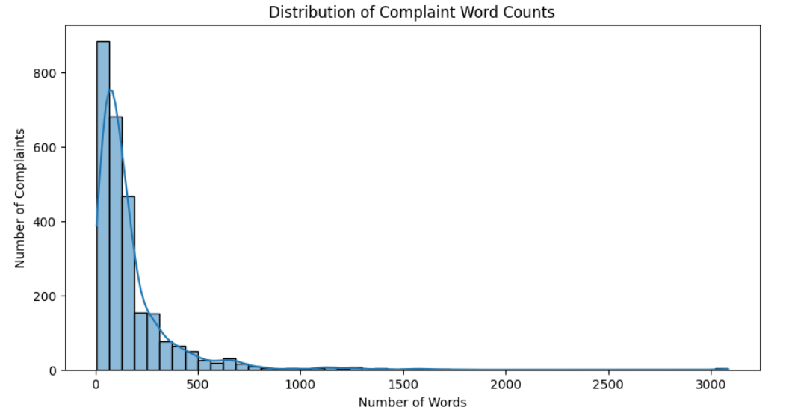
Fig.2. Distribution of Complaint Word Counts
The frequency analysis of complaint descriptions highlights the most commonly occurring terms in the dataset. As shown in Fig.3, words such as “credit,” “report,” “consumer,” “information,” and “reporting” occur frequently, indicating that credit-reporting-related issues are a major theme in the complaints. The presence of repeated terms such as “xxxx” suggests that sensitive information has been anonymized in the dataset. Overall, the results indicate that consumer complaints are strongly associated with credit reporting, personal information, and reporting-related concerns.

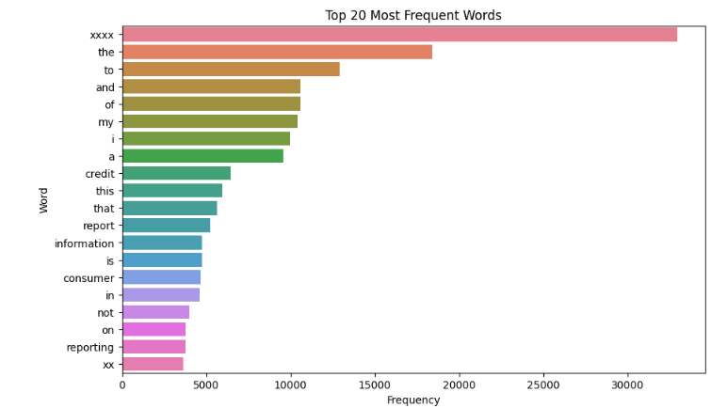
Fig. 3. Top 20 Most Frequent Words in Consumer Complaints
The word cloud provides a visual representation of the most prominent terms appearing in consumer complaints. Fig. 4 shows that terms such as “credit,” “report,” “consumer,” “reporting”, “information,” “identity,” “company,” and “agency” appear prominently, reflecting their high frequency within the complaint text. The dominance of credit- and reporting-related terminology suggests that consumers frequently experience problems involving credit reports, reporting agencies, and the accuracy or handling of personal information. The visualization also reveals recurring anonymized terms represented by “xxxx,” which indicates the removal of personally identifiable information.
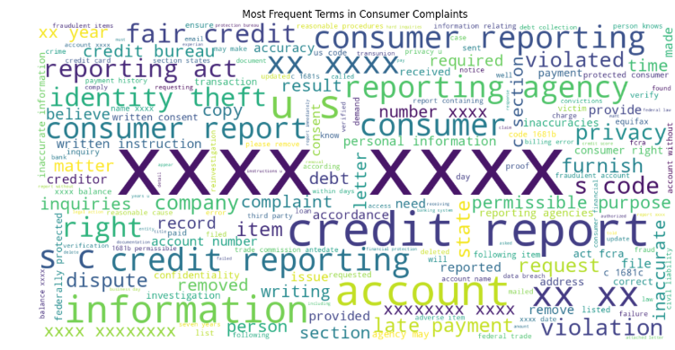
Fig. 4. Word Cloud of Most Frequent Terms in Consumer Complaints
The distribution of complaint sub-issues shows the specific problems most frequently reported by consumers. As presented in Fig.5, “Reporting company used your report improperly” is the most frequently occurring sub-issue, followed by “Information belongs to someone else” and “Their investigation did not fix an error on your report.” Other notable complaints include incorrect account information, incorrect account status, and unrecognized credit inquiries. These findings indicate that inaccurate or improperly handled credit-report information represents a significant concern among consumers. The results can help identify priority areas for improving credit-reporting practices and resolving consumer complaints more effectively.

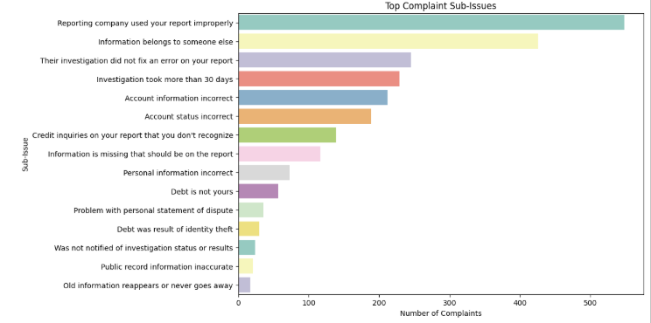
Fig. 5. Distribution of Top Complaint Sub-Issues

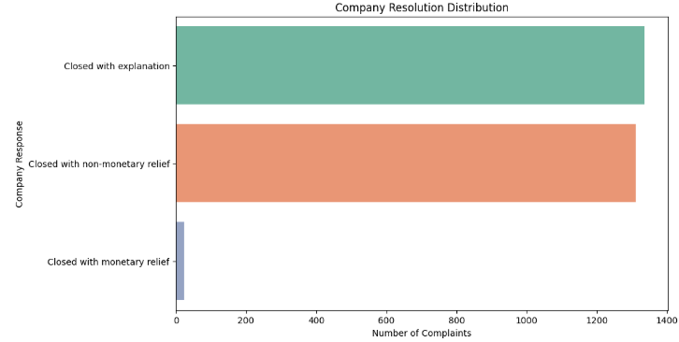
Fig.6.

5.2 Baseline comparision

To evaluate the performance of different machine learning classifiers, three baseline models were implemented using Term Frequency–Inverse Document Frequency (TF-IDF) feature extraction: Logistic Regression (LR), Linear Support Vector Machine (SVM), and Random Forest (RF). These models were evaluated using accuracy, macro-precision, macro-recall, and macro-F1 score.
Logistic Regression was used as a linear classification baseline, while Linear SVM was included to evaluate the effectiveness of a margin-based classifier on sparse TF-IDF features. Random Forest was used as a tree-based ensemble baseline to compare its performance with the linear models.
The results indicate that Linear SVM achieved the highest accuracy of 64.86%, whereas Logistic Regression obtained the highest macro-F1 score of 46.61%. Random Forest achieved an accuracy of 62.06% and a macro-F1 score of 41.56%. Although Linear SVM performed best in terms of accuracy, Logistic Regression provided a better balance between macro-precision and macro-recall, resulting in the highest macro-F1 score among the three classifiers. These findings show that the choice of baseline model affects classification performance and that accuracy alone may not fully represent performance across classes.

Table:1Baseline comparison for classification
Classification Model | Accuracy | Macro-Precision | Macro-Recall | Macro-F1
TF-IDF + Logistic Regression | 0.6112 | 0.4595 | 0.4770 | 0.4661
TF-IDF + Linear SVM | 0.6486 | 0.4336 | 0.4368 | 0.4346
TF-IDF + Random Forest | 0.6206 | 0.4138 | 0.4175 | 0.4156

To evaluate the effectiveness of the proposed complaint retrieval framework, a comparative analysis was conducted against two baseline approaches: TF-IDF with Cosine Similarity and Sentence-BERT (SBERT) with Cosine Similarity. These methods represent traditional lexical similarity-based retrieval and semantic embedding-based retrieval, respectively. The TF-IDF approach identifies relevant complaints based on the importance and overlap of terms, whereas SBERT captures semantic relationships between complaint descriptions using sentence embeddings. The proposed hybrid method combines semantic similarity with structured contextual information, including product, sub-product, issue, sub-issue, company, and timeliness attributes, to improve the ranking of relevant complaints.
The methods were evaluated using Precision@10, Recall@10, Mean Reciprocal Rank (MRR), and Normalized Discounted Cumulative Gain at 10 (nDCG@10). Precision@10 measures the proportion of relevant complaints among the top ten retrieved results, while Recall@10 measures the proportion of relevant complaints retrieved within the top ten. MRR evaluates the position of the first relevant result, and nDCG@10 assesses the ranking quality by assigning greater importance to relevant results appearing near the top of the ranked list.

Table:2 Comparative evaluation of complaint retrieval methods.

Method | Precision@10 | Recall@10 | MRR | nDCG@10
TF-IDF + Cosine Similarity | 0.5610 | 0.0289 | 0.8150 | 0.8329
SBERT + Cosine Similarity | 0.6060 | 0.0288 | 0.8833 | 0.8733
Proposed Hybrid | 0.8910 | 0.0709 | 0.9701 | 0.9661

The results show that the proposed hybrid method achieves the highest values across all four evaluation metrics. It obtains a Precision@10 of 0.8910, compared with 0.5610 for TF-IDF and 0.6060 for SBERT. This represents relative precision improvements of approximately 58.82% and 47.03%, respectively. The proposed method also achieves an MRR of 0.9701 and an nDCG@10 of 0.9661, indicating that relevant complaints are generally ranked closer to the top of the result list under the evaluation protocol.
Recall@10 increases from 0.0289 for TF-IDF and 0.0288 for SBERT to 0.0709 for the proposed method. Although this is a substantial relative improvement, the absolute recall remains low, indicating that many relevant complaints are not retrieved within the top ten results. Therefore, the results support improved top-ranked retrieval performance, but further investigation is required to improve the coverage of relevant complaints. Overall, the comparison indicates that incorporating structured contextual information alongside semantic similarity can improve complaint retrieval performance relative to the two baseline methods.

The performance of the proposed hybrid complaint retrieval method was compared with two baseline approaches: TF-IDF with cosine similarity and SBERT with cosine similarity. The evaluation was conducted using four ranking metrics: Precision@10, Recall@10, Mean Reciprocal Rank (MRR), and normalized Discounted Cumulative Gain at 10 (nDCG@10). As illustrated in Fig. 7, the proposed hybrid method achieved a Precision@10 of 0.8910, Recall@10 of 0.0709, MRR of 0.9701, and nDCG@10 of 0.9661. In comparison, SBERT with cosine similarity obtained 0.6060, 0.0288, 0.8833, and 0.8733, respectively, while TF-IDF with
cosine similarity achieved 0.5610, 0.0289, 0.8150, and 0.8329 for the same metrics.
The results show that the proposed hybrid approach outperformed both baseline methods in Precision@10, MRR, and nDCG@10. Its higher Precision@10 indicates that a larger proportion of the top-ten retrieved complaints were relevant, while the improved MRR and nDCG@10 values indicate better positioning and ranking of relevant complaints. The proposed method also achieved higher Recall@10 than either baseline, suggesting that it retrieved a greater proportion of relevant complaints within the top-ten results under the adopted evaluation criterion. These improvements suggest that incorporating contextual information alongside semantic similarity can enhance complaint retrieval performance compared with using either baseline approach independently.

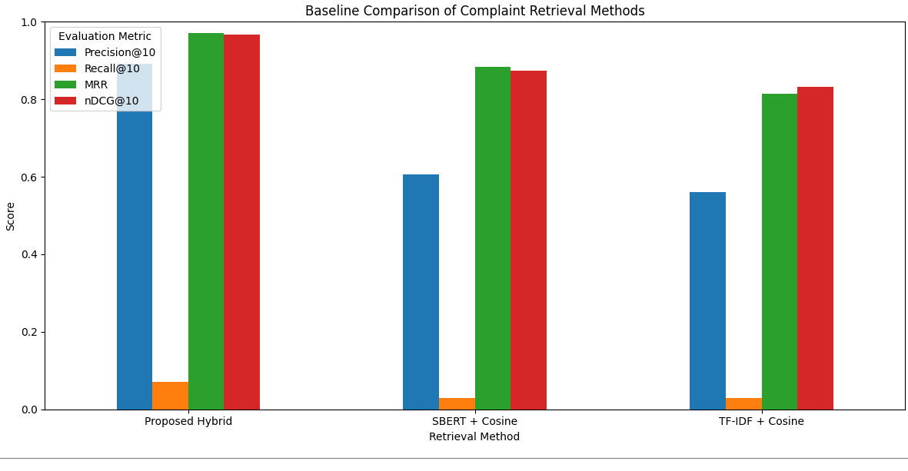

Fig 7.Baseline Comparison of Complaint Retrieval Method

4.3 Ablation Study
Figure 8 presents the ablation study conducted to evaluate the individual contributions of semantic similarity and contextual information to the complaint recommendation system. Four configurations were evaluated: Semantic Only (100:0), Context Only (0:100), Hybrid (50:50), and Proposed Hybrid (70:30). The performance was assessed using Precision@10, Recall@10, Mean Reciprocal Rank (MRR), and normalized Discounted Cumulative Gain at 10 (nDCG@10).The results
indicate that the Context Only configuration achieved the highest performance, with a Precision@10 of 0.9260, Recall@10 of 0.2351, MRR of 0.9800, and nDCG@10 of 0.9800. The Hybrid (50:50) configuration obtained a Precision@10 of 0.8670, Recall@10 of 0.1768, MRR of 0.9500, and nDCG@10 of 0.9455. In comparison, the

Proposed Hybrid (70:30) configuration achieved scores of 0.7720, 0.1528, 0.9308, and 0.9256 for the respective metrics. The Semantic Only configuration recorded the lowest Precision@10 (0.4950), while its Recall@10, MRR, and nDCG@10 were 0.0935, 0.7973, and 0.7984, respectively.
These findings suggest that contextual attributes contribute substantially to recommendation performance under the current evaluation setup. However, the 70:30 configuration did not outperform the Context Only or 50:50 configurations. Therefore, the results do not establish the 70:30 weighting scheme as optimal. Further evaluation using a consistent and independently defined relevance criterion is necessary to determine the most effective balance between semantic similarity and contextual information.

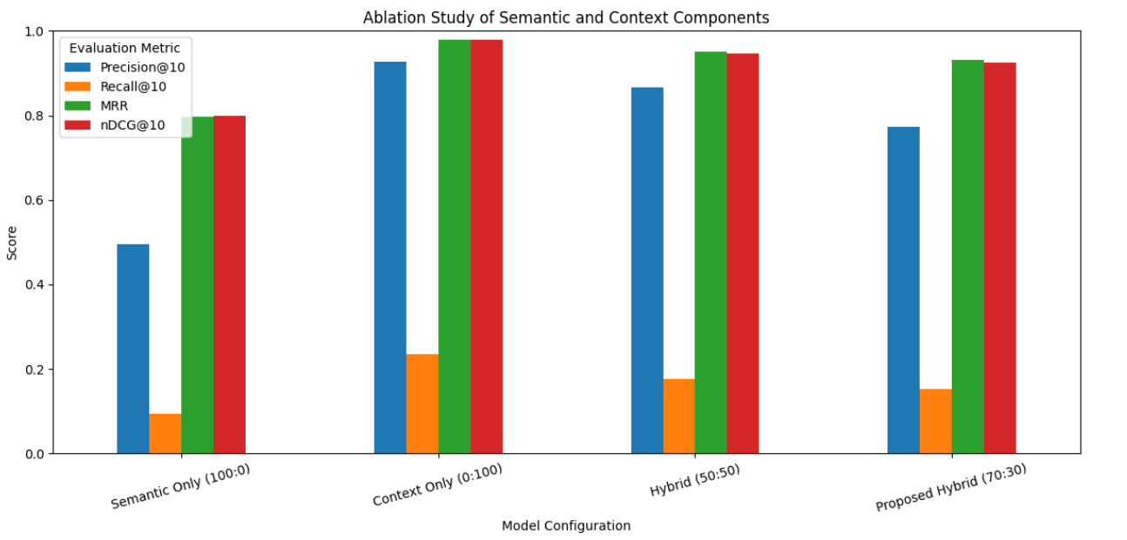

Fig. 8. Ablation study of semantic and context components

An ablation study was conducted to evaluate the individual contributions of semantic similarity and contextual information to the complaint retrieval system. Four configurations were considered: Semantic Only, Context Only, Hybrid (50:50), and Proposed Hybrid (70:30). Their performance was evaluated using Precision@10, Recall@10, Mean Reciprocal Rank (MRR), and normalized Discounted Cumulative Gain at 10 (nDCG@10).
The Semantic Only configuration achieved a Precision@10 of 0.4950, Recall@10 of 0.0935, MRR of 0.7973, and nDCG@10 of 0.7984. The proposed model configuration achieved the highest scores across all four metrics, with Precision@10 of 0.9260, Recall@10 of 0.2351, MRR of 0.9800, and nDCG@10 of 0.9800. The Hybrid (50:50) configuration recorded a Precision@10 of 0.8670, Recall@10 of 0.1768, MRR of 0.9500, and nDCG@10 of 0.9455. The context only configuration achieved a Precision@10 of 0.7720, Recall@10 of 0.1528, MRR of 0.9308, and nDCG@10 of 0.9256.
The results indicate that proposed model information plays a substantial role in complaint retrieval performance under the current evaluation setup. Although, the Proposed Hybrid (70:30) outperforms the Context Only or Hybrid (50:50) configurations,it doesn’t necessarily mean that assigning a higher weight to semantic similarity improve retrieval effectiveness. Therefore, further weight-sensitivity experiments and validation using an independently defined relevance criterion are required to identify the most effective configuration for the proposed system.

Table 3. Ablation study comparing semantic and contextual components across different complaint retrieval configurations

Configuration | Precision@10 | Recall@10 | MRR | nDCG@10
Semantic Only | 0.4950 | 0.0935 | 0.7973 | 0.7984
Proposed Hybrid (70:30) | 0.9260 | 0.2351 | 0.9800 | 0.9800
Hybrid (50:50) | 0.8670 | 0.1768 | 0.9500 | 0.9455
Context only | 0.7720 | 0.1528 | 0.9308 | 0.9256

4.4 Semantic Retrieval Performance
The complaint narratives were converted into semantic embeddings and used for similarity-based retrieval. The

system successfully retrieved the most relevant historical complaints from the indexed complaint collection shown in fig.9. For the selected query, “I found an unauthorized inquiry on my credit report that I do not recognize”, the highest semantic similarity was 0.822083 for complaint ID 9996796.
The first five retrieved cases obtained semantic similarity scores of 0.822083, 0.785892, 0.779472, 0.777194, and 0.796845, respectively. The retrieved cases were related to
credit-reporting and credit-inquiry issues, demonstrating that the semantic retrieval stage was able to identify historically relevant complaints

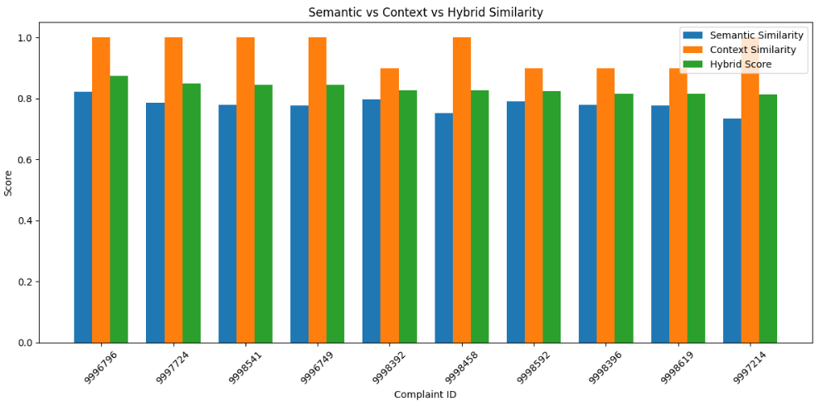

Fig. 9. Semantic, Contextual and Hybrid Similarity Scores of Retrieved Complaints

4.4.1 Context-Aware Hybrid Ranking
To improve the relevance of semantic retrieval, structured complaint attributes were incorporated into the ranking process. The system uses product, sub-product, issue, sub-issue, company, timely response and state information to calculate contextual similarity.The final hybrid score was calculated using a weighted combination of semantic and contextual similarity using eq.9.
$${ H}_{i}=0.7S_{i}+0.3C_{i} (9)$$where $S_{i}$represents semantic similarity and $C_{i}$represents contextual similarity.

For the selected complaint, the highest-ranked historical case, complaint ID 9996796, obtained a semantic similarity of 0.822083, contextual similarity of 1.00, and hybrid score of 0.875458. The next three cases obtained hybrid scores of 0.850124, 0.845631, and 0.844036, respectively shown in fig.3.The fifth case obtained a hybrid score of 0.827791 with a contextual similarity of 0.90. These results demonstrate that the contextual information contributes additional evidence when ranking semantically similar complaints.

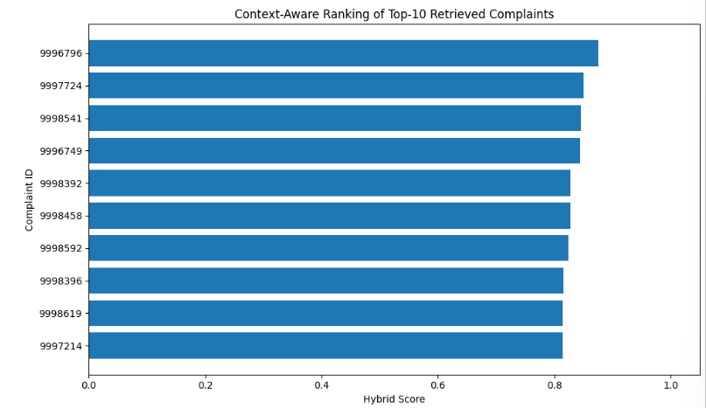

Fig. 10. Context-Aware Ranking of Top-10 Retrieved Complaints

4.4.3 Resolution Recommendation performance
After ranking the historical complaints, the system analyzes their recorded company_response values to determine possible resolution pathways. The hybrid scores of complaints belonging to each resolution category are aggregated, and the resulting scores are normalized to obtain recommendation confidence as shown in fig.9.
The system generated three resolution pathways. Closed with non-monetary relief was ranked first with a resolution score of 276.8624 and a confidence of 52.98%. Closed with explanation was ranked second with a score of 243.6036 and a confidence of 46.62%. Closed with monetary relief was ranked third with a score of 2.0682 and a confidence of 0.40%.
Therefore, for the selected credit-report inquiry complaint, the system recommends Closed with non-monetary relief as the most likely historical resolution pathway, followed by Closed with explanation.
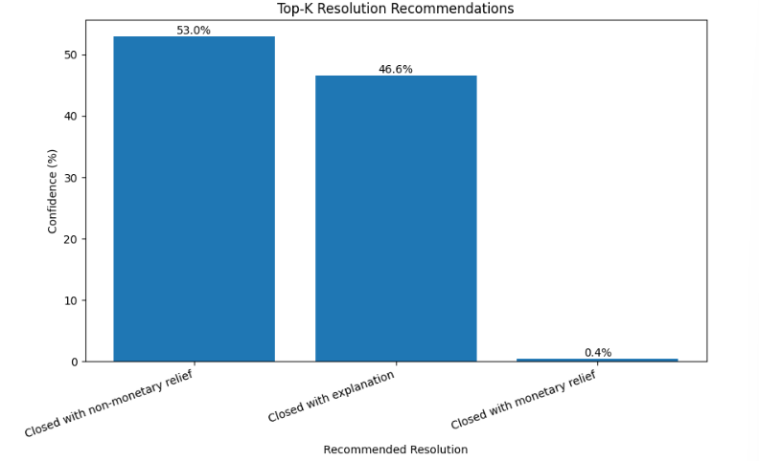

Fig. 11.Top-K Resolution Recommendations

4.3.4 Historical Resolution Distribution
The resolution labels in the analyzed 1,000 records were distributed across three company response categories. Closed with non-monetary relief accounted for 518 cases, Closed with explanation accounted for 475 cases, and Closed with monetary relief accounted for 7 cases as shown in fig.10.
This distribution indicates that the dataset contains a substantial imbalance in historical resolution outcomes, particularly for monetary relief.
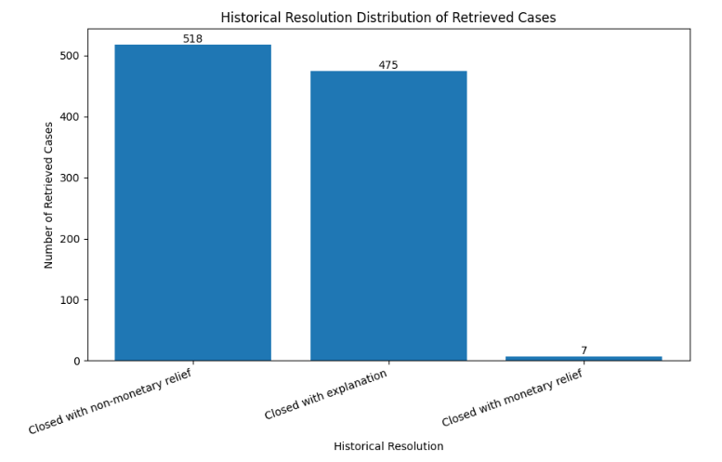

Fig.12. Historical Resolution Distribution of Retrieved Complaints

4.3.5 Explainable AI and Contextual Evidence
The contextual evidence analysis was performed to identify the attributes supporting the recommendation of complaints related to the issue “Closed with non-monetary relief.” The analysis examines the percentage of matching supporting cases for each contextual feature, including product, sub-product, issue, sub-issue, company, and timely status. As illustrated in Fig. 13, the timely attribute achieved the highest matching percentage of 100%, followed by product at 94.4% and sub-product at 94.2%. The issue attribute recorded 53.5%, while the company attribute showed 49.2%. In contrast, the sub-issue attribute exhibited a substantially lower matching percentage of 1.0%. These results demonstrate how contextual evidence can help explain the attributes associated with a retrieved complaint. The high matching percentages for timely status, product, and sub-product indicate strong agreement on these attributes among the supporting cases examined. The lower percentages for company and issue suggest comparatively less consistent matching, while the sub-issue attribute contributes limited matching evidence in this example. This analysis provides an interpretable view of the contextual features associated with the recommendation, helping users understand which attributes show stronger or weaker agreement with the retrieved complaints. However, these percentages represent matching evidence within the evaluated cases and should not be interpreted as causal importance or overall model accuracy.

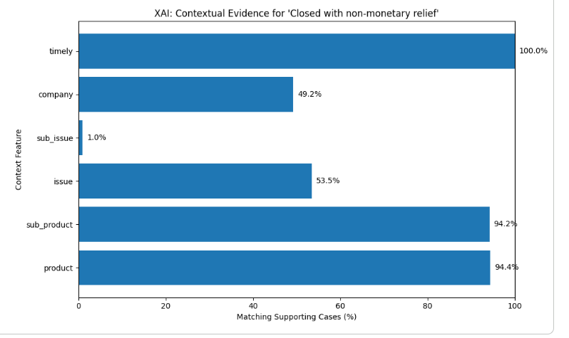
Fig. 13. XAI: Contextual Evidence Supporting the Recommended Resolution
Feature contribution analysis was performed to examine the relative influence of semantic similarity and contextual information in ranking the retrieved complaints. The proposed hybrid configuration assigns a weight of 70% to semantic similarity and 30% to contextual information. As shown in Fig. 14, semantic contribution remains higher than context contribution across all ten retrieved complaints. The semantic contribution scores range approximately from 0.51 to 0.58, whereas the context contribution scores range from 0.27 to 0.30.
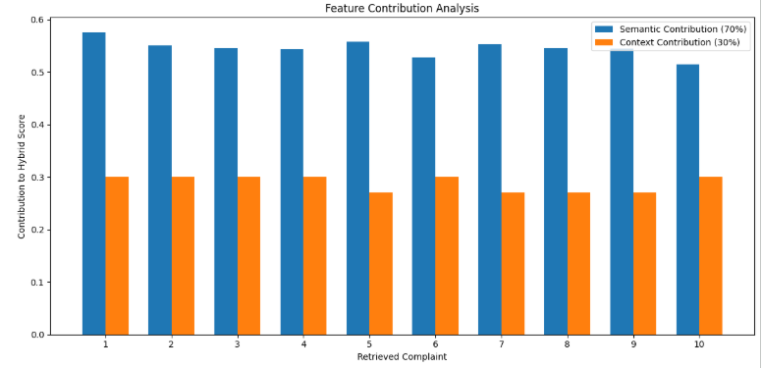
Fig. 14.Feature contribution analysis showing the semantic and contextual
The results indicate that semantic similarity is the dominant component in the proposed ranking approach, helping identify complaints with similar textual meaning, while contextual information provides additional support for ranking complaints based on their associated attributes. The relatively consistent contribution values across the retrieved complaints suggest that both components participate in the ranking process, with semantic similarity receiving greater emphasis under the 70:30 weighting scheme. This analysis illustrates how the hybrid approach combines semantic and contextual signals to produce complaint recommendations. However, these contribution scores represent the model's configured component contributions and should not be interpreted as independent evidence of improved recommendation accuracy.

4.5Discussion
The experimental results demonstrate that the proposed system can combine semantic understanding with structured complaint context to retrieve and rank historically relevant consumer complaints. The selected example involving an unauthorized credit-report inquiry produced several highly relevant historical cases, with the highest semantic similarity reaching 0.822083.
The results further demonstrate the usefulness of incorporating structured information into the retrieval process. The hybrid ranking assigns 70% weight to semantic similarity and 30% to contextual similarity, allowing the system to retain the importance of the complaint narrative while using structured attributes to refine the ranking. For example, complaint ID 9996796 achieved a semantic similarity of 0.822083 and a context similarity of 1.00, resulting in a hybrid score of 0.875458. An important contribution of the proposed framework is the transition from similarity retrieval to resolution recommendation. Rather than merely returning historical complaints, the system aggregates the hybrid scores of cases according to their historical company_response and converts these aggregated scores into recommendation confidence. This resulted in Closed with non-monetary relief being ranked first at 52.98%, followed by Closed with explanation at 46.62%.
However, the resolution distribution shows a substantial class imbalance, with only 7 of the 1,000 analyzed records corresponding to monetary relief compared with 518 non-monetary-relief cases and 475 explanation cases. Therefore, the very low confidence of 0.40% for monetary relief should be interpreted in the context of its limited representation in the analyzed data rather than as evidence that monetary relief is generally inappropriate.
The contextual evidence analysis further strengthens the interpretability of the recommendation. The high matching percentages for product (94.4%), sub-product (94.2%), and timely response (100%) indicate strong agreement between the query and the cases supporting the recommended pathway. In contrast, the relatively low matching percentages for issue and sub-issue show that textual and broader contextual similarity can remain important even when more specific categorical fields do not match strongly.
The SHAP component provides another level of interpretability by explaining the contribution of semantic and contextual similarity to the hybrid score. Because the implemented ranking function explicitly uses these two components, SHAP can provide a direct explanation of their influence on the ranking.
Overall, the experimental findings demonstrate the feasibility of a retrieval-based consumer complaint recommendation framework in which historical complaint narratives are transformed into semantic representations, relevant cases are retrieved and contextually re-ranked, and their historical resolution patterns are converted into actionable recommendations. The framework therefore extends complaint analysis beyond conventional classification toward case-based resolution guidance with explainability.

5.CONCLUSION
This study presented a context-aware consumer complaint resolution recommendation system designed to support the analysis and resolution of large-scale consumer complaints. Unlike conventional complaint-management approaches that primarily focus on classification, sentiment analysis, prioritization, or routing, the proposed framework utilizes historical complaint-resolution information to recommend relevant resolution pathways for newly received complaints.
The proposed framework integrates textual and structured complaint information within a unified pipeline. Complaint narratives are processed using both conventional TF-IDF representations for baseline evaluation and transformer-based Sentence-BERT embeddings for semantic representation. The use of Sentence-BERT enables the identification of historically similar complaints beyond exact keyword matching. FAISS-based vector retrieval further provides an efficient mechanism for retrieving relevant historical complaints from the complaint repository.
To improve the relevance of retrieved cases, semantic similarity is combined with structured contextual information such as product, issue, sub-issue, company, and other available complaint attributes. The resulting hybrid ranking mechanism enables the system to identify historical cases that are not only semantically similar but also contextually relevant to the new complaint. The company responses associated with the highly ranked historical cases are subsequently utilized to generate Top-K resolution pathway recommendations.
The experimental evaluation demonstrates the usefulness of combining semantic representations, historical case retrieval, and contextual information for complaint resolution recommendation. The comparison with the conventional TF-IDF and Logistic Regression baseline further provides evidence of the advantages of moving from lexical complaint representation toward semantic retrieval. In addition, the explainability component provides supporting historical cases and feature-level evidence, thereby improving the transparency of the generated recommendations.
Overall, the proposed framework demonstrates that historical consumer complaint records can be transformed from a passive data repository into an evidence base for resolution assistance. The system therefore provides a practical foundation for intelligent complaint-management applications in which customer-service personnel can use ranked historical evidence to support more consistent and efficient resolution decisions. Importantly, the generated recommendations should be interpreted as decision-support recommendations based on historical resolution patterns rather than guaranteed predictions of future company responses.

5.1 FUTURE WORK
Although the proposed framework provides a foundation for context-aware complaint resolution recommendation, several opportunities remain for further research. First, future studies can investigate domain-specific transformer models trained or fine-tuned on financial complaint narratives. Such models may improve the representation of specialized financial terminology, complaint-specific language, and complex customer–institution interactions.
Second, the retrieval and recommendation components can be extended using Retrieval-Augmented Generation (RAG) and large language models. A future system could retrieve relevant historical complaints and generate concise, evidence-grounded explanations while maintaining the retrieved cases as supporting evidence. This could improve the usability of recommendations without replacing the underlying evidence-based retrieval mechanism.
Third, future work can incorporate temporal and company-specific information into the recommendation process. Resolution practices and institutional policies may change over time; therefore, temporally weighted retrieval and company-specific resolution patterns could improve the relevance of recommendations and reduce dependence on outdated historical cases.
Fourth, the framework can be extended to support real-time complaint processing. Integration with streaming complaint-management systems could enable newly received complaints to be automatically embedded, indexed, retrieved, ranked, and presented to customer-service personnel with minimal processing delay.
Another important direction is human-in-the-loop evaluation. Future studies can involve complaint-handling professionals to evaluate the usefulness, relevance, consistency, and interpretability of the recommended resolution pathways. Such evaluation would provide practical validation beyond automated retrieval and ranking metrics.
Future research can also investigate multilingual and cross-domain complaint resolution. Extending the framework to complaints expressed in multiple languages and applying it to other service domains could examine the generalizability of the proposed approach.
Finally, future work should explore mechanisms for detecting unseen complaint types, insufficient historical evidence, and potentially biased historical responses. Incorporating confidence estimation, uncertainty detection, and fairness-aware recommendation mechanisms could prevent the system from producing overly confident recommendations when suitable historical evidence is unavailable.
These extensions can further develop the proposed framework from an offline historical retrieval system into a robust, adaptive, explainable, and real-time intelligent decision-support system for consumer complaint management.

Data Availability: The Consumer Financial Protection Bureau (CFPB) Consumer Complaint Dataset (RPAD) analyzed during this study is publicly available and can be accessed at:
https://www.consumerfinance.gov/data-research/consumer-complaints/

REFERENCES
[1] Dr Srinivasa Rao Pallapu, A. Akhila, A. Varshasri, Ch. Viritha. Smart Complaint Prioritization System using NLP and Machine Learning for E-Governance. International Journal for Research Trends and Innovation (IJRTI), Vol. 11, Issue 4, April 2026, ISSN 2456-3315. DOI: IJRTI2604091.

[2] Anurag Saha, Aadarsh Chaure, Aayush, Aditya Bodhe, Prof. T.D. Bhagat. Automated Complaint Classification and Routing Using NLP and Machine Learning. International Journal of Innovative Research in Technology (IJIRT), Vol. 11, Issue 6, November 2024, ISSN 2349-6002. DOI: IJIRT169187.

[3] Drashti Desai, Abhishek Kumar. AI-Based Complaint Management System Using NLP and Machine Learning. International Journal of Research Publication and Reviews (IJRPR), Vol. 7, Issue 4, April 2026, pp. 1626-1633. DOI: https://doi.org/10.55248/gengpi.07.0426.10838

[4] Le Li, Wei Chong Choo, Rony Kumar Datta, Md. Mehedul Islam Sabuj, Md. Shamim Hossain. Understanding Complaint Behavior in Mobile Banking: A Psychological and AI-Based Analysis of Emotional Drivers. Acta Psychologica, Vol. 264, 2026, Article 106435. DOI: https://doi.org/10.1016/j.actpsy.2026.106435

[5] Derya Uysal, Doğacan Toka, Elif Bozkurt, Osman Kumaş, Hasan Hüseyin Yılmaz. Enhancing Financial NLP with Supercomputing: Spell Correction and Domain-Specific BERT Pretraining. Procedia Computer Science, Vol. 267, 2025, pp. 176-186.
DOI: https://doi.org/10.1016/j.procs.2025.08.244

[6] Athira, Adith M., Deepa Gupta. Effective Complaint Detection in Financial Services through Complaint, Severity, Emotion and Sentiment Analysis. Procedia Computer Science, Vol. 258, 2025, pp. 2220-2231. DOI: https://doi.org/10.1016/j.procs.2025.04.472

[7] Neeraj Yadav, Peter Madzík, Arash Shahin, Dominik Zimon. Empowering the Voice of Individual Consumers in the Era of Digitalisation and Quality 4.0. International Journal of Quality & Reliability Management, 2026. DOI: https://doi.org/10.1108/IJQRM-12-2024-0461

[8] Apoorva Singh, Sriparna Saha, Md. Hasanuzzaman, Kuntal Dey. Multitask Learning for Complaint Identification and Sentiment Analysis. Cognitive Computation, Vol. 14, 2022, pp. 212-227. DOI: https://doi.org/10.1007/s12559-021-09844-7

[9] Thomas De Cleen, Philippe Baecke, Frank Goedertier. The Influence of Emotions and Communication Style on Customer Satisfaction and Recommendation in a Call Centre Context: An NLP-Based Analysis. Journal of Business Research, Vol. 189, 2025, Article 115192. DOI: https://doi.org/10.1016/j.jbusres.2025.115192

[10] G. Alarifi, M. F. Rahman, and M. S. Hossain, “Prediction and analysis of customer complaints using machine learning techniques,” International Journal of E-Business Research, vol. 19, no. 1, pp. 1–25, 2023, doi: 10.4018/IJEBR.319716.

[11] D. Vaishnav, M. Neethinayagam, A. Khaire, and J. Woo, “Predictive analysis of CFPB consumer complaints using machine learning,” arXiv preprint arXiv:2407.06399,2024,doi:10.48550/arXiv.2407.06399. https://doi.org/10.48550/arXiv.2407.06399

[12] Z. Wang, S. Zhu, and X. Chen, “From complaint narratives to monetary relief: A hybrid machine learning framework for CFPB consumer complaints,” arXiv preprint arXiv:2606.22664, 2026, doi: 10.48550/arXiv.2606.22664.
https://doi.org/10.48550/arXiv.2606.22664

[13] K. I. Roumeliotis, N. D. Tselikas, and D. K. Nasiopoulos, “Think before you classify: The rise of reasoning large language models for consumer complaint detection and classification,” Electronics, vol. 14, no. 6, Art. no. 1070, 2025, doi: 10.3390/electronics14061070.
https://doi.org/10.3390/electronics14061070

[14] P. Gao, C. Yang, N. Sun, and R. Zitikis, “NLP-based consumer complaint assessment: Synthetic data generation, featurization, and evaluation metrics,” Applied Sciences, vol. 16, no. 12, Art. no. 5992, 2026, doi: 10.3390/app16125992.
https://doi.org/10.3390/app16125992

[15] M. Shin, J. Kim, and J. Shin, “The adoption and efficacy of large language models in US consumer financial complaints,” Nature Human Behaviour, vol. 10, pp. 669–680, 2026, doi: 10.1038/s41562-026-02409-4.
https://doi.org/10.1038/s41562-026-02409-4

[16] P. Gao, N. Sun, X. Wang, C. Yang, and R. Zitikis, “NLP-based detection of systematic anomalies among the narratives of consumer complaints,” Journal of Operational Risk, vol. 19, no. 2, pp. 79–104, 2024, doi: 10.21314/JOP.2024.004.
https://doi.org/10.21314/JOP.2024.004

[17] S. Khedkar and S. Shinde, “Deep learning and ensemble approach for praise or complaint classification,” Procedia Computer Science, vol. 167, pp. 449–458, 2020, doi: 10.1016/j.procs.2020.03.254.
https://doi.org/10.1016/j.procs.2020.03.254

[18] W. Xu, Z. Yao, Y. Ma, and Z. Li, “Understanding customer complaints from negative online hotel reviews: A BERT-based deep learning approach,” International Journal of Hospitality Management, vol. 126, Art. no. 104057, 2025, doi: 10.1016/j.ijhm.2024.104057.
https://doi.org/10.1016/j.ijhm.2024.104057

[19] M. Trusov, D. M. Goldenberg, and A. K. Bodapati, “A transformer-based framework for customer complaint analytics,” European Journal of Operational Research, vol. 319, no. 2, pp. 562–579, 2024, doi: 10.1016/j.ejor.2023.10.028.
[20] C. Vairetti, I. Aránguiz, S. Maldonado, J. P. Karmy, and A. Leal, “Analytics-driven complaint prioritisation via deep learning and multicriteria decision-making,” European Journal of Operational Research, vol. 312, no. 3, pp. 1108–1118,2024.DOI:10.1016/j.ejor.2023.08.027.
[21] X. Tian, I. Vertommen, L. Tsiami, P. van Thienen, and S. Paraskevopoulos, “Automated Customer Complaint Processing for Water Utilities Based on Natural Language Processing—Case Study of a Dutch Water Utility,” Water, vol. 14, no. 4, Art. 674, 2022.
DOI:10.3390/w14040674.
[22] M. U. Tahsin, M. S. Hossain Shanto, and R. M. Rahman, “Combining Natural Language Processing and Federated Learning for Consumer Complaint Analysis: A Case Study on Laptops,” SN Computer Science, vol. 4, no. 5, Art. 537, 2023.DOI:10.1007/s42979-023-01989-6.
[23] J. Won and J. W. Bae, “Natural Language Processing-Based Customer Complaint Classification and After-Sales Service Category Selection,” Journal of the Korea Institute of Information and Communication Engineering, vol. 29, no. 6,pp.745–754,2025.DOI:10.6109/jkiice.2025.29.6.745.
[24] J. Won and J. W. Bae, “Topic Modeling-based Customer Complaint Quality Classification and Service Improvement Strategies,” Journal of the Korea Institute of Information and Communication Engineering, vol. 30, no. 1, pp. 1–12, 2026.
DOI:10.6109/jkiice.2026.30.1.1.
[25] P. Jain, S. Tripathi, T. Garg, N. Sadashiv, N. C. Kundur, M. Phadke, M. Gaikwad, et al., “An intelligent transformer-based framework for bilingual financial complaint classification,” Scientific Reports, vol. 16, Art. 20594, 2026.
DOI:10.1038/s41598-026-51771-w.
[26] D. B. Dayta and E. B. Barrios, “Semiparametric latent topic modeling on consumer-generated corpora,” Annals of Data Science, vol. 12, no. 6, pp. 1941–1963, 2025.
DOI:10.1007/s40745-025-00587-y.
[27] J. Zhang, Z. Du, S. Sun, and colleagues, “Perception of customer satisfaction and complaints based on BERT Topic and interpretable machine learning: evidence from hotels in Xi’an,” Current Issues in Tourism, vol. 28, no. 19, pp. 3168–3190,2025.
DOI:10.1080/13683500.2024.2389308.
[28] M. F. Tuna and Y. Görmez, “Classification of Customer Complaints using Convolutional Neural Network Based Deep Learning Method,” Bingöl University Journal of Economics and Administrative Sciences, vol. 8, no. 1, 2024.
[29] F. Bozyiğit, O. Doğan, and D. Kılınç, “Categorization of Customer Complaints in Food Industry Using Machine Learning Approaches,” Journal of Intelligent Systems: Theory and Applications, vol. 5, no. 1, 2022.
DOI:10.38016/jista.954098.
[30] W. Jinzheng, Y. Ying, and Y. Bengong, “Classifying Customer Complaints Based on Multi-head Co-attention Mechanism,”2023.DOI:10.11925/infotech.20963467.2022.0258.
[31] Y. Helmy, M. Ashraf, and L. Abdelhamid, “Assessing the Effectiveness of Various Text Classification Algorithms in Customer Complaint Classification: An Informative Resource for Data Scientists and Data Analysts,” International Journal of Computer Applications, vol. 186, no. 2,pp.8–16,2024.DOI:10.5120/ijca2024923346.
[32] P. A. Olujimi and A. Ade-Ibijola, “NLP techniques for automating responses to customer queries: a systematic review,” Discover Artificial Intelligence, vol. 3, Art. 20, 2023.DOI:10.1007/s44163-023-00065-5.
[33] A. Adak and B. Pradhan, “Sentiment Analysis of Customer Reviews of Food Delivery Services Using Deep Learning and Explainable Artificial Intelligence: Systematic Review,” Foods, vol. 11, no. 10, Art. 1500, 2022.
DOI:10.3390/foods11101500.
[34] D. S. [et al.], “Natural language processing for analyzing online customer reviews: a survey, taxonomy, and open research challenges,” PeerJ Computer Science, vol. 10, e2203,2024.DOI:10.7717/peerj-cs.2203.

